**Boston University**

**Electrical & Computer Engineering**

**EC463 Senior Design Project**

First Semester Report

DOSeye



Submitted to

Dr. Darren Roblyer

Boston University

44 Cummington Mall

Boston, MA 02215

roblyer@bu.edu

by

Team 3

DOS Amigos

Team Members

Michael Ethier [methier@bu.edu](mailto:methier@bu.edu)

Solomon Utain [sutain@bu.edu](mailto:sutain@bu.edu)

Ami Vyas [amivyas@bu.edu](mailto:amivyas@bu.edu)

Alexander Wang [amwang@bu.edu](mailto:amwang@bu.edu)

Submitted: December 12, 2016

#### Table of Contents

Executive Summary ii

1.0 Introduction 1

2.0 Concept Development 2

3.0 System Description 4

4.0 First Semester Progress 7

5.0 Technical Plan 8

6.0 Budget Estimate 12

7.0 Attachments 13

7.1 Appendix 1 – Engineering Requirements 13

7.2 Appendix 2 – Gantt Chart 14

7.3 Appendix 3 – Other Appendices 15

# Executive Summary

DOSeye

Team 3 – Dos Amigos

The DOSeye is a small, comfortable, wearable monitor for breast cancer patients which uses light spectroscopy technology to measure metabolic changes of a tumor during chemotherapy. It will include a light source and photodetector that will send light through breast tissue to gain information about the scattering and absorption properties of the tissue. The source will be a four wavelength Vertical Cavity Surface Emitting Laser (VCSEL) and the detector will be an Avalanche Photodiode (APD), both of which have not previously been used with this technology and are expected to significantly improve the quality of the data received.

# Introduction

Breast cancer is one of the most common forms of cancer in women, at about 12.5% of women having some form of it in their lifetime. Chemotherapy is often administered to shrink malevolent tumors prior to surgery; however, patient response to chemotherapy is not always guaranteed. Chemotherapy treatments have the potential to either work against a patient’s cancer, elicit no response, or even make the cancer worse. This shows a need to detect the response of a tumor as quickly as possible to determine if chemotherapy should be continued or if the treatment should instead be revised.

One current technology to quickly monitor the state of a tumor during chemotherapy is Diffuse Optical Spectroscopic Imaging (DOSI). This requires a light source which modulates the intensity of light at a range of frequencies and directs it into tissue which contains a tumor. A detector which can measure the phase shift and change in intensity of the light is placed at a point a certain distance away from the light source and the signals are amplified and analyzed.

The current sensor used for DOSI technology is big, bulky, and needs to be operated by a nurse, practitioner, or doctor. Measurements are time-consuming, taking around 30 minutes to an hour. Data from the measurements is manually saved on a USB flash drive and transferred to the lab computer - a cumbersome process. This project aims to make this sensor into a small, comfortable, wearable device which can take constant measurements throughout the chemotherapy session without the assistance of a medical professional. This will save time and increase the amount of data taken during the session without sacrificing accuracy or precision. We will also be able to store data recorded from the probe into an organized database on the cloud which will store information in individual patient files and allow for remote data processing.

# Concept Development

To minimize the size of the DOSI probe that is currently used in the clinic, we have taken an approach of building a new system that uses the same basic DOSI technology as the current probe. In order to minimize the size of the probe, new electronics are required. The avalanche photodiode that we will use is both small and accurate in the frequency ranges that we will use, as seen in Fig. 1.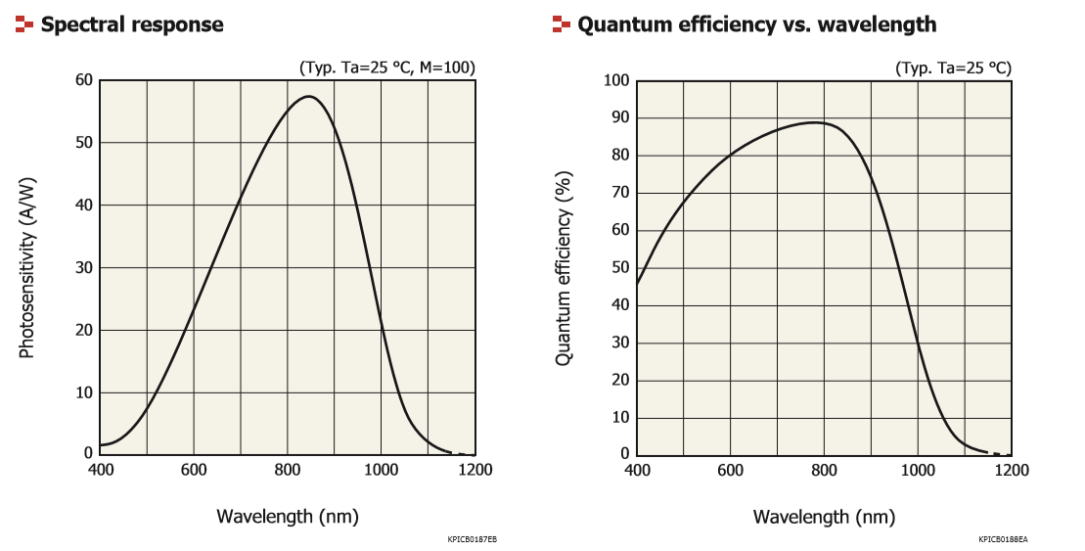

*Figure 1: The spectral response and efficiency of the APD are greatest in the range of frequencies that we require: 600-800 nm.*

The four wavelength Vertical Cavity Surface Emitting Laser that we are using will emit light at the wavelengths that the four major components of breast tissue (oxyhemoglobin, deoxyhemoglobin, fat, and water) show absorption peaks: 660nm, 680nm, 775nm, 795nm. This device is custom-made for this purpose. The source and detector will be placed on a small, rigid PCB which will be capable of operating these two devices. To ensure patient comfort, the housing for the probe will be surrounded by a soft exterior. The source and detector should be able to sit completely flush with the surface of the skin, so as to not obstruct or interfere with the light going from source to detector. It will also include a strap to remove the need for the probe to be held in place by a medical professional.

Firstly, we will develop two separate circuit boards and assess the behavior of the APD and VCSEL separately. Then, we will combine them into one circuit board and develop a housing for the unit. One alternative solution we considered was using a flexible PCB for our source-detector pair, but we upon further analysis we learned that the flexible material used would be risky for supporting a 200 V DC input.

Through our weekly meetings with Professor Roblyer, we had come up with the problem of testing and designing our device when it is based off of two major components, the VCSEL and the APD, yet the APD is more complex than the VCSEL and would require more time to study and testing in order to implement in our design. From here we decided it would be best to create separate circuit boards for the VCSEL and APD for most of the development of our device. This would allow us to not only split up the work, but to also work on the two components simultaneously and build a VCSEL PCB first while we are still testing the APD Evaluation board.

For the problem of patient data storage, we have decided on a solution that features cloud-based remote access. This will store raw patient data into a HIPPA compliant database that associates data files with individual patient medical records. We were initially going to create this database software ourselves, but decided to use existing software, namely OpenEMR. OpenEMR as software is compliant with HIPPA standards for patient data security. This substantially simplifies the prospect of being able to use an electronic medical record system within an actual clinic. However, this software will require modifications and additions in order to suit our needs, so software design is necessary even with the use of open source software. Developing our own software would involve delving into advanced cybersecurity beyond the scope of this project.

# System Description

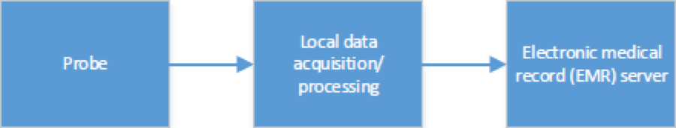

*Figure 2: Level 0 Block Diagram*

As seen in Fig. 2, the probe is placed on tissue and sends data to a computer to be processed in MATLAB. The processed data is then sent to an electronic medical record server.

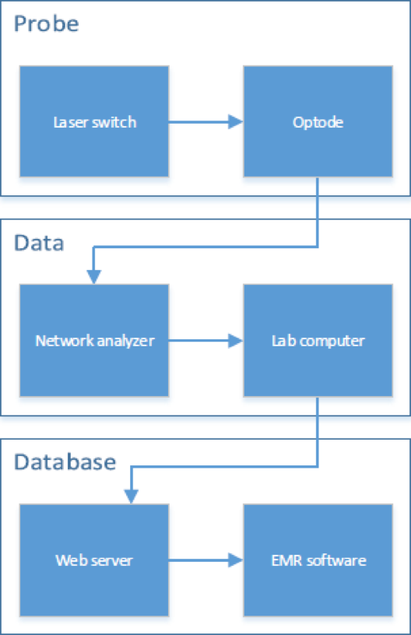

*Figure 3: Level 1 Block Diagram*

Fig. 3 consists of three main components which are the probe, the data acquisition/processing setup, and the database. The probe consists of the source and detector which are the VCSEL and APD respectively. The probe then sends a signal to the network analyzer which is then sent to the lab computer. The lab computer then processes the data and finds the optical properties of the tissue. This data is then sent to the web server.

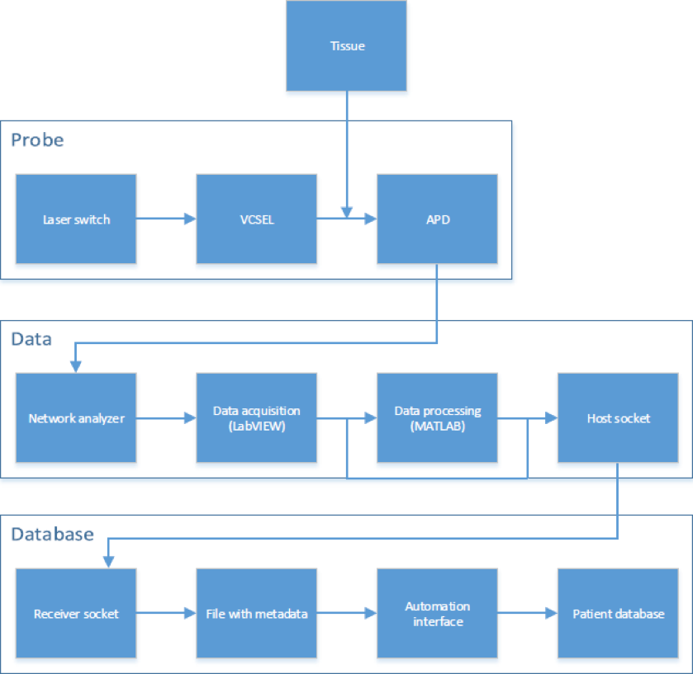

*Figure 4: Level 2 Block Diagram*

As seen in Fig. 4, the laser switch supplies power to the VCSEL and this determines which wavelengths output. The VCSEL emits light into the tissue and light then scatters in a banana shaped form within the tissue and then diffuses out into the APD. The APD sends a signal to the network analyzer which is connected to the lab computer. The computer uses LabVIEW to acquire the data and output it all in an excel file. The excel file is then processed in a MATLAB code which finds the corresponding absorption and scattering coefficients of the tissue. This data is then sent to the database using a host and a receiver socket.

The host injects metadata with the file transfer, which the server end looks for. This metadata relates to a patient record and a folder in which to store it. The automation interface reads this metadata and appends the file to the database under the appropriate patient record.

# First Semester Progress

At the start of the semester, we researched more into Diffuse Optical Spectroscopic Imaging so that we’d have a better understanding of what our probe will actually do. We also conducted research on the Vertical Cavity Surface Emitting Laser (VCSEL) and the Avalanche Photodiode (APD) in order to understand why these are the two main components that we’re using. We then learned how to test the optode in Professor Roblyer’s lab. In order to do this we used the three wavelength VCSEL and the APD Board that we were supplied. We created a schematic and several designs for the four wavelength VCSEL PCB using ExpressPCB and we were able to order them directly from ExpressPCB. These VCSEL PCB designs are shown in Appendix 3. The socket components for the VCSEL and the RF connectors were supplied by our client so we were able to solder the VCSEL PCB right away. A continuity test was performed to make sure that all of the connections were correct. We used the spectrometer to make sure that the VCSEL output the correct four wavelengths which are 660 nm, 680 nm, 775 nm, and 795 nm. This was done for the first part of our deliverable test and the graphs are shown in Appendix 5. We tested the APD Eval Board from Hamamatsu using the four wavelength VCSEL. The Eval Board has two separate switches, one which is for background correction and another which is for low vs high gain. From our results, we decided that the background correction setting is definitely something we’ll incorporate on our APD PCB because when background correction is turned on, the signal has much less noise. We have also tested the low(x1) vs high(x20) gain setting and we prefer the low gain setting because high gain also amplifies the noise along with the rest of the signal but we are still conducting this testing because we are looking to find out what the pros of using high gain are. The switch testing was done as the second part of our deliverable testing. These graphs are shown in Appendix 6. We have started to design the APD PCB, so far we have found all of the components for the board and we are currently doing continuity testing on the Hamamatsu APD board to see how the switches are configured because we are going to keep this configuration on our APD board also.

The web server is completely set up and configured. It is a LAMP server, meaning it is a Linux server running Apache, MySQL, and PHP. Because this is a test machine, the server is physically a headless Raspberry Pi running Debian Jessie on a microSD card, networked via 10/100 Ethernet. The domain *doseye.tk* has been assigned to the server via a multistep internet request flow. The domain name registry (i.e. the service that distributed the doseye.tk URL) points to the nameservers of a DNS service, which points to the IP address specified by the Pi. The Pi actively communicates with the DNS service, updating its IP address in 15 minute intervals as well as immediately at boot-up. This was accomplished by running an HTTP request script as a Cron job. To this effect the IP address in the DNS service always points to the Pi, despite the Pi having a dynamic IP rather than a dedicated static IP.

Configuring the web server is an essential step in hosting the EMR. Being a LAMP server, it is fully configured to run a web interface and support database functionality, which directly translates to our project goal of having a cloud-accessible patient database.  
 The electronic medical record is currently installed on the server and is functional as a web service accessible at *www.doseye.tk/openemr*. We have been successful in verifying that OpenEMR has the functionality required by our project by creating a patient file and uploading files/documents to patient-associated medical records. This is easily accomplished through the EMR’s web interface.

The fact that OpenEMR supports creating patient records as well as adding files to these records means we have HIPPA compliant database software to work with, and it is possible to meet our requirement of having a HIPPA compliant EMR. Moving forward we need to write patient file upload scripts in order to automate database appending, as currently the only way to add files to the database is to do it manually through the web interface. Whether learning to modify the SQL database schema or making a script to navigate the web interface, I will be able to make this software work for our project goals.  
 Host-client communication is easily implemented through SSH/SFTP. The web server runs an SSH service, to which any client with appropriate credentials can connect and transfer a file to the server over an SSH session.

SSH file transfer is a good rudimentary step in moving files from the data acquisition machine to the server to then be added to a patient database. The next step would be to write files to the server as they are being written, rather than writing the file in its entirety on the host machine and then transferring it over. This can potentially be implemented through socket communication or using existing Linux tools such as *rsync*. In the meantime, simple yet secure SSH file transfer is an effective means of pushing data files to the server.

# Technical Plan

Our plan to complete our projects is divided into the tasks below which follow the Gantt Chart in Appendix 2.

Task 1. APD Evaluation Board Continuity Test

Continuity testing shall be performed on the current evaluation board in order to determine how the switches are connected to the traces and components on the board. Lead: Alex

Task 2. EMR Interfacing and Automation

OpenEMR, while supporting database functionality, only supports uploads through its web interface. Our requirements call for files to be automatically appended to a patient record once the server receives data, so we must interface with OpenEMR to do this without human intervention. To accomplish this we have two tentative solutions. One solution is to learn the database schema used in the software and use a script to modify the database directly. Our other solution is to use a script to navigate the EMR’s web interface to emulate a manual upload. Lead: Solomon

Task 3. Obtain Necessary circuit components via DigiKey

The connector for the high voltage supply still need to be found on DigiKey or other similar service, as well as the connector for the DC voltage supply and the switches for the gain settings and DCFB settings. Once these parts are all found, these components, along with the resistors, capacitors, and filters already found, shall be ordered for the APD PCB. Lead: Alex

Task 4. Design and order APD PCB

A PCB that will implement the APD and components ordered from digikey shall be designed using ExpressPCB. The main focus of the design will be to have the APD on one end of the board, and all of the other components on the other end, so that the APD will be able to be placed flush against the phantom when taking measurements. Once this design is complete, the board will be ordered. Lead: Alex

Task 5. Solder APD

Once the PCB arrives from ExpressPCB, the APD and other necessary components shall be soldered onto it. Lead: Alex

Task 6. Research 3D Printing

Research shall be conducted on 3D printer techniques in order to create a housing for the probe. This research will include the cost for various techniques and materials, as well as what materials are viable to use with 3D printing, and what materials would work best for a wearable device that will house electronics. Lead: Mike

Task 7. Research High Voltage DC/DC converter/Compact High Voltage Supply

Extended research on high voltage DC/DC convertors will be conducted over winter break. One of the reach goals is to be able to plug in the probe directly to an outlet. This is because the high voltage supply currently in use is very large and cumbersome so it may be best to place a DC/DC convertor within the probe. Further investigation has to be done before we decide on this because we need to figure out if this can actually be done in a safe way first. Lead: Alex

Task 8. LabVIEW and MATLAB server communication

The lab computer must send data to the server as it is recorded. This would involve modifying the current data acquisition code (LabVIEW) and data processing code (MATLAB) to allow for network communication and file transfer to the server. It might also involve a separate script running on the lab computer that communicates with the server. Ideally the server would be sent a file as it is written, receiving it in real time. If this proves problematic, files would be sent over once they are finished being written to. Lead: Solomon

Task 9. Continuity Test (APD PCB Prototype)

Continuity Testing shall be performed to ensure all of the connections are correct on the APD PCB Prototype. This will ensure that the board was printed and cut correctly, and that all of the components were properly soldered on. Lead: Alex

Task 10. Switch Testing Without Optical Fiber

Measurements of the intensity-modulated light from the VCSEL at all four wavelengths will be taken through a phantom. These measurements will be taken at each of the different combinations of settings for the gain switch and the DCFB switch on the APD PCB prototype. This testing will determine which switch settings are optimal and whether the switches should be kept in the design or “hard set” in future PCBs. Lead: Ami

Task 11. Output Testing Without Optical Fiber

Measurements of the intensity-modulated light from the VCSEL at all four wavelengths will be taken through a phantom. The measurements will be repeated through both output port 1 and output port 2 on the APD PCB prototype. This data will be compared with each other and data from previous measurements of the APD Prototype board and Hamamatsu’s APD board in order to determine if there is a significant difference between the output ports and whether or not both need to be used in order to obtain all of the information from the signal. Lead: Ami

Task 12. System Integration

Once all software components are completed individually, we will test all components together as a system. Lead: Solomon

Task 13. Design More Compact APD PCB

One of the main goals is to design a comfortable wearable probe and designing a compact probe directly affects this. A smaller probe will be more comfortable than a large and bulky probe. In order for the probe to be small, compact PCBs that will fit into a small housing need to be designed but at the same time EMI has to be kept in mind because by creating more compact PCBs this may affect the probe’s performance. Lead: Alex

Task 14. Source-Detector Separation Testing

Once the APD PCB is finished, this will allow source-detector separation testing to be done. Source-detector separation will be done in order to find the separation that has the best signal to noise ratio. This separation will then be used for PCB that has both the APD and VCSEL on it. Lead: Ami

Task 15. Remote Processing

The server would be capable to processing data files, outsourcing this functionality from the lab computer. This can branch off into multiple paths of action, including recompiling the MATLAB processing script to work on the Pi, porting the script’s functionality to a language supported by the Pi, or migrating the system running on the server to a different server environment, possibly AWS. Lead: Solomon

Task 16. Design and Create Single Optode Housing

A housing will be 3D printed, most likely in EPIC. It will be designed with the proper material for heat tolerance of the electronics. It will be built with comfort in mind since the probe is supposed to be used for a few hours at a time. There will probably be an outer layer so that the probe is comfortable. Lead: Mike

Task 17. Source-Detector Layout Testing

Testing will be performed and measurements will be taken with the VCSEL board and APD board at various geometries and distance with relation to each other. This testing will determine the optimal distance for the source-detector separation as well as possible optode geometries for the possible implementation of multiple sources and/or detectors. Lead: Ami

Task 18. Redesign and Create Single Optode Housing

If a different source-detector layout than the existing setup is required or desired, than the probe housing shall be redesigned and recreated in order to accommodate this. Additionally, if there were any problems regarding the material used, a new material may be implemented at this stage. Lead: Mike

Task 19. Signal-to-noise testing

The signal to noise testing will be an ongoing process once the APD PCB is finished. This will be done to make sure that the probe meets all of the requirements from Professor Roblyer. It’s an ongoing process because testing will be done to make sure that any changes done to the probe such as different source detector separations and different source detector layouts either improve the performance of the probe or don’t affect the performance. Lead: Ami

# Budget Estimate

|  |  |  |
| --- | --- | --- |
| **Item** | **Description** | **Cost** |
| 1 | VCSEL | Supplied by Customer |
| 2 | APD | Supplied by Customer |
| 3 | Printed Circuit Board – VCSEL | $80 |
| 4 | Printed Circuit Board – APD | $60 |
| 5 | Components – resistors, capacitors, filters, switches | $15 |
| 6 | Low and high voltage connectors | $15 |
| 7 | RF and UMCX connectors | $10 |
| 7 | High voltage supply/converter | $25 |
| 8 | Enclosure/housing | $40 |
| 9 | Raspberry Pi | $30 |
| 10 | MicroSD card | $25 |
| 11 | Server peripherals (Power supply, cables, etc.) | $10 |
| 12 | Server enclosure | $10 |
|  | **Total Cost** | **$320** |

The VCSELs and the APDs are provided to us by Professor Roblyer. In total, we have access to two VCSELs and 12 APDs. Since these pricey components are provided and other circuit elements are not very expensive, our budget is not very constrained. Our primary expense will be printed circuit boards.

# Attachments

# Appendix 1 – Engineering Requirements

Team #3 Team Name: DOS Amigos

Project Name: DOSeye

|  |  |
| --- | --- |
| **Requirement** | **Value, range, tolerance, units** |
| Optode Pair | Precision: <5% Drift over 2 hours of 𝜇s and 𝜇a Accuracy: <10% error compared to “gold standard” Signal-to-noise ratio 10:1 |
| APD PCB Board (Detector) | 200 V DC supplied to board  Must be safe for patient wear  Successfully detect light sent from source |
| VCSEL PCB Board (Source) | Output four separate wavelengths of light  Follow ANSI laser safety standards |
| Housing | Can hold source and detector flush with the skin  Comfortable for patient wear, doesn’t need to be held in place  Material safe to use with high voltages in PCBs |
| Electronic Medical Record | Must be HIPPA compliant  Must transfer raw data  Classify data into separate and confidential patient records |

# Appendix 2 – Gantt Chart

# https://lh6.googleusercontent.com/5lYFUdzM0VgiW6ciQ-BoIRRxw-lhG6sLdoiQ-XBuCHbkCa5cSm2pgdbB2vWebM28EaF-2XZ6l5al4Ru34mJwmW1iJCArDRyh7YS6b0VqhYrB_JfFT-2nfmHaNTYDPYnuJkSadn8G

# Appendix 3 – Other Appendices

**7.3.1 – VCSEL PCB**

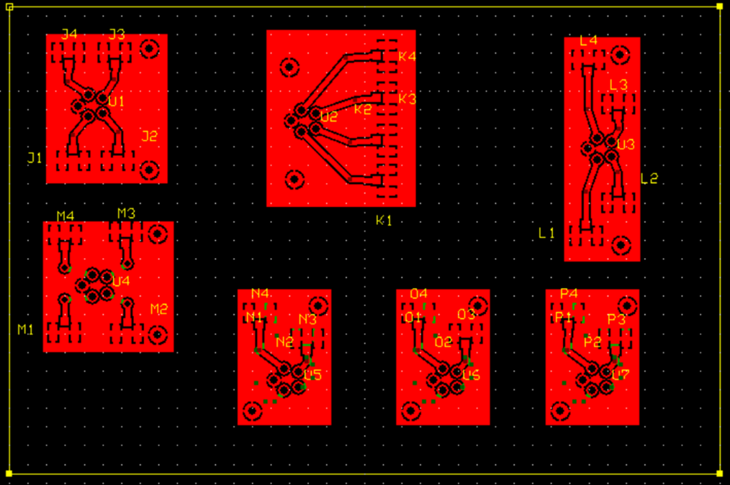

* + 1. **– APD Block Diagram**

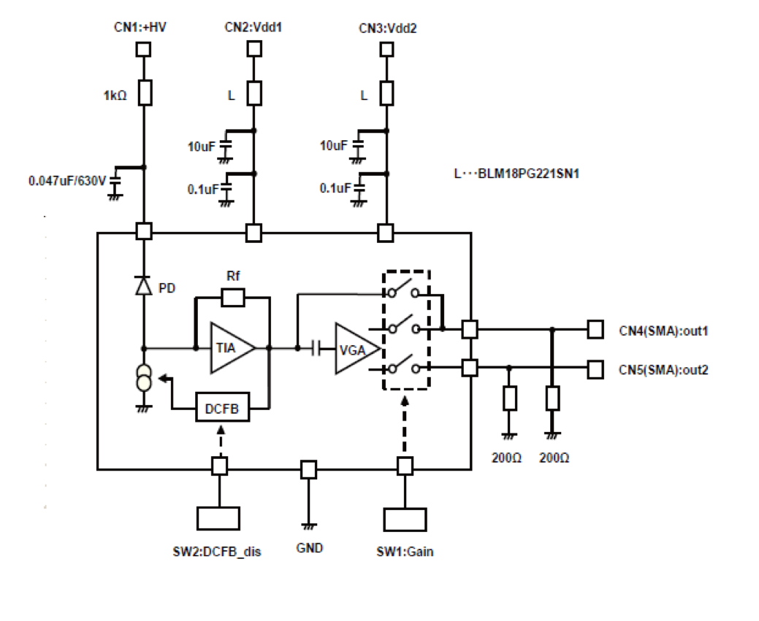

* + 1. **– First Deliverable VSCEL testing**

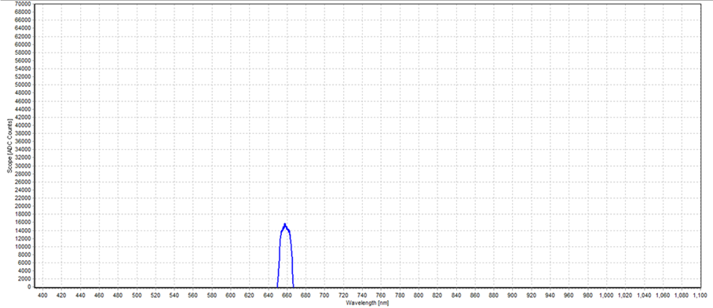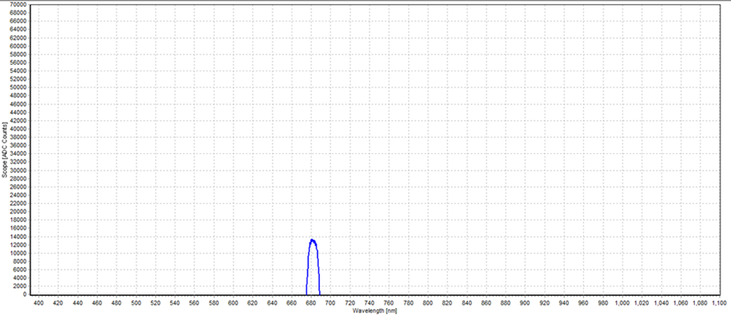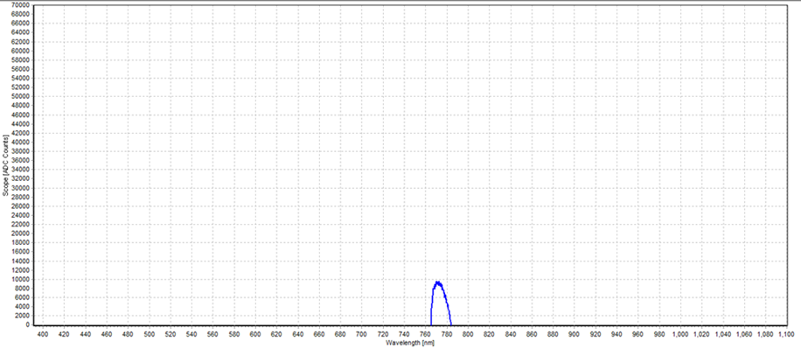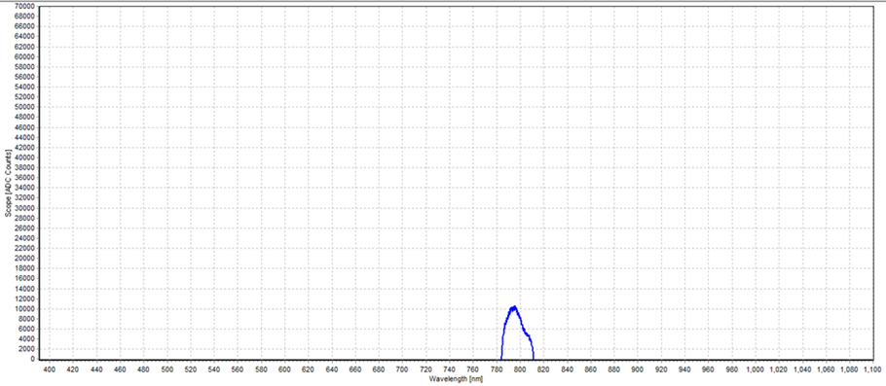

660nm

775nm

680nm

795nm

* + 1. **Appendix 6 – First Deliverable APD Testing**

